**ANNUAL TREE MORTALITY SURVEY PROTOCOLS**

**ForestGEO-SCBI 2020**

**NOTE: Due to the coronavirus circumstances in 2020 we implemented few modifications to this census, mainly:**

* **No coring of dead trees (if time allows, it will be done once survey is completed)**
* **Included chvi species that were mistakenly excluded in 2019.**

**What to bring to the field**:

1. Datasheet, either printed or in electronic format (use iPad provided).
2. Camera (find it in drawer with other electronics)
3. Binoculars, **IMPORTANT** to check live status of very tall trees and to distinguish between leaves of lianas or tree under inspection.

***Tree data (pre-existing data)***

***NOTE:*** *The pre-existing data should be embedded in the new datasheets that you bring to the field. See updated script to create datasheets (GitHub\SCBI-ForestGEO-Data\tree_mortality\R_script\Script_to_produce_datasheet)*

**Codes 2018:** refers to stem conditions given in 2013 (last core census): **A**: alternate pom (point of measurement), **B**: stem broken above breast height, **C**: dead above 1.3m, **F**: Incorporated into fence, **G**: ID to Genus certain, **I**: stem irregular where measured, **J**: Bent, **L**: leaning stem, **M**: multiple stems, **main**; main stem, **P**: prostrate stem, **S**: secondary stem, **V**: Vine, **X**: stem broken below 1.3 m. Dead codes: **DS**: Dead, stem standing, **DC**: Dead, stem fallen, **DT**: Only tag found, **DN**: No plant nor tag found.

**DBH (mm):** Diameter at breast height in millimeters. Given for all trees as last core census.

**Live status in previous mortality census:** Include status.YEAR for at least the last 3 censuses, for example, in 2020 include status for 2017, 2018, and 2019. These are the codes used: A (Alive), AU (Alive unhealthy), DS, DC, DN, and PD. PD: “previously dead”: tree found dead during a previous census. If the tree is found alive, change status and write in comments. If DN, try to relocate the tree again and indicate the FAD.

**PROCEDURE**

At the SCBI plot, a blue re-bar located in the SW corner gives the quadrat name (3 or 4 digits). Locate the rebar and orientate yourself (N-S). Locate all trees within the quadrat you are working on and make sure you complete all trees before moving to the next quadrat. Coordinates (x, y) are given in reference to a 20x20m square.

1. Locate stem on datasheet and classify it as “A” (alive), “AU” (alive unhealthy), “DC” (dead on the ground), or “DS” (dead standing), “DN” (dead not found).

2. If the status is “AU”

1. Record FADs in order of importance (at least 1 factor)- See FAD codes below.
2. Record crow.position (D, CD, I,S,OG).

AU is used for trees that are alive but noticeably unhealthy (e.g. fallen and uprooted but not yet dead).

**Notes**:

Sometimes a tree recorded dead in a previous year is “back to life”. If a dead tree is alive in the current census (meaning you are %100 sure it is alive), mark the tree as A and make a note in comments.

Avoid giving a tree the DN status; you need to find all trees in the list.

3. If a stem is dead:

1. **Take pictures:** Take a picture of every dead tree found. Take a picture of the tag first then make 2-3 pics of main FADS. Make nice close-ups if any insect or insect galleries are found.
2. **Measure DBH** (in mm). If stem has fallen, measure it later using a big caliper (find one in Radiotracking lab).
3. Record **Percentage of crown** still intact:

1 = only 0-25% of the crown is intact (almost gone)

2 = 26-50% of the crown is intact

3 = 51-75% of the crown is intact

4 = 76-100% of the crown is intact (none or few branches lost)

1. Record **Crown Position:**

*Dominant* (**D**): Crown extends above the general level of the canopy receiving full sunlight.

*Codominant* (**CD**): Crown forms main level of canopy, tree receives full sunlight from above.

*Intermediate* (**I**): Shorter trees with smaller crowns, receive little light from above and none from sides.

*Suppressed* (**S**): Crown below canopy, small crown receives no direct light.

*Open grown* (**OG**): Crown on open areas of the stand.

1. Record Liana load.

0 = lianas absent

1 = up to 25% of the tree crown covered by lianas

2 = 26–50% liana cover

3 = 51–75% liana cover

4 = 76–100% liana cover.

1. Record Factors associated with death or FAD in order of importance.

To scrutinize the FAD’s look at “*Guide to Identify Tree Diseases at the SCBI-CTFS Forest-GEO Plot*”.

|  |  |
| --- | --- |
| **FAD Categories:**  **U**= Unable to determine cause of death  *Mechanical damage*  **B**= Broken stem (note cause, indicate level on tree)  **CR**= Crushed by other tree or tree parts  **UP**= Uprooted tree (root bole exposed)  **S**= Slope failure (evident landslide even if small)  **L**= Lightning (tree splitting, straight scars from above)  **Fi**= Fire (stem charred, fire scars on bark) | *Biological agents*  **AN**= Animal damage (specify animal if possible)  **BB**=Bark beetles present, beetle galleries.  **I=**  Insect infection (e.g. EAB, other)  **DF**= Complete defoliation ((record crown condition using Smith/Flower method below 1 – 5 scale).  **F**= Fungi visible (give names if known)  **K**= Canker or swelling present (cause by fungi)  **LF**= Leaf damage (look for leaf spots, blotch, etc.)(new 2019)  **R**= Rotting stem.  **R1**= Root damage  **R2**= Armillaria root disease |

1. For all *Fraxinus* species and trees code chvi (dead or alive): All trees ≥1 cm will be visited during a mortality survey.

* Record **crown position** (D, DC, I, S, OG)
* Estimate **crown thinning** via visual assessment per Smith/Flower 2013:

1 = healthy tree with no symptoms of decline, no defoliation

2 = slight reduction in leaf density (thinning), yet all top branches exposed to sunlight have leaves

3 = thinning canopy and some top branches exposed to sunlight are defoliated (<50% dieback)

4 = >50% defoliation/dieback

5 = Dead tree with no leaves in canopy (excluding epicormic sprouting)

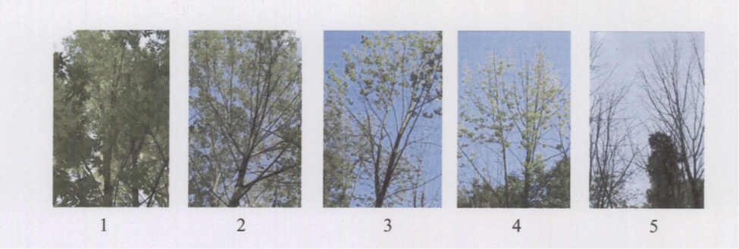

* **Epicormic shoots**: Use the 6-class dwarf mistletoe rating system (Hawksworth 1977) to evaluate epicormic growth

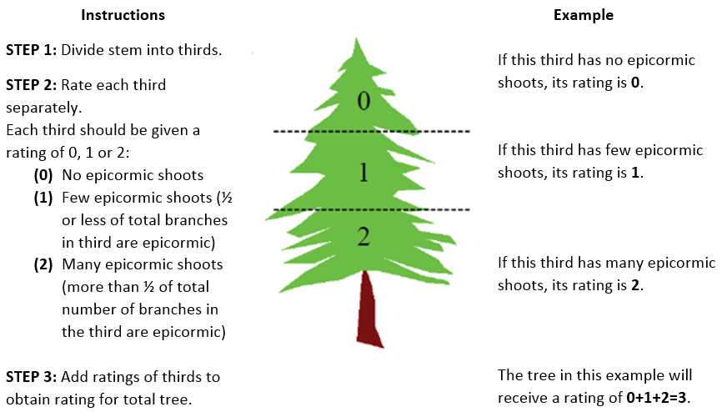

* Record **EABF** (Emerald Ash Borer Factors), separated by comma.

VB = Vertical bark splitting

SS = Stump sprouts

AS = Ash snap of the branches/limbs

W = Bark blonding from woodpecker predation. In comment section, write percentage estimate.

DE = D-shaped exit hole presence

If DE are present then count all visible D-shaped holes around the circumference of the tree in an area ~50 cm long at breast height and record this number. At SCBI almost all tags are located at 1.3 m, so use the tag as reference to visually define the 50 cm area.

**CORING:**

If time allows, cores will be taken at the end of survey.

1. Take 1 **core**, aiming to hit the center: only at breast height and for the following species: ceca, amar, cofl, ploc, prav, rops, saal, and all Quercus.
2. Save in straws for future analyses. Label each straw with tag #, species, and date.
3. Mark in datasheet ‘cored’=yes/no.
4. Follow steps in document “Coring_instructions_SCBI” located in ‘Protocol’ folder.